**Automated Deployment to AWS with**

**Jenkins and Bit bucket**

**Index**

1. **Architecture**
2. **Pre-requisites**
3. **Bit bucket Application Repository & Jenkins Integration**
4. **Bit bucket and Jenkins Repo workflow**
5. **Jenkins job setup**
6. **Installations and Configurations commands**

**Architecture**

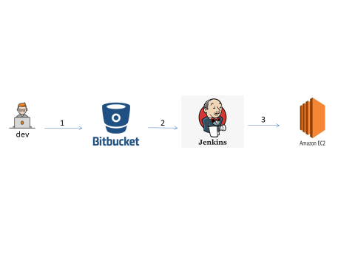

**Explanation:**

1. Developer commits an application code update to the application BITBUCKET repository.

2. Jenkins picks up the code change in BITBUCKET on its next polling interval and kicks off new build process and deploy application in to AWS EC2 servers

**Prerequisites**

Must have access to below accounts

1. AWS account
2. Bit bucket account and repository

**Bit bucket Application Repository & Jenkins Integration**

Application repository should be available in bit bucket repository and add Jenkins integration to Bit Bucket by using web hooks.

**Bit bucket and Jenkins Repo workflow:**

1. Create an Empty Repository and create one more branch and name it as development branch
2. Developer will create one more feature branch and push the code into it.
3. Developer will create a merge request to development branch.
4. Team lead will review the code and merge with development branch. Once the code is merged with development branch pre-configured Jenkins job will trigger the build and code will deploy to staging environment.
5. After successful deployment of code in staging environment team lead will give notification to Quality Assurance team to do testing.
6. After providing the sign-off for testing from QA team lead will raise the merge request for development branch to master branch.
7. Team lead will again review the code and merge with master branch.
8. After merging to master pre-configured Jenkins job will trigger and deploy the code to production environment and application will go live.
9. For cross-validation team lead again request the QA team to test again the application in production environment.

**Jenkins job setup:**

1. Install latest java and Jenkins software in EC2 instance using putty and configure the Jenkins username and password install recommend plugins.
2. Create a new job and select type as Freestyle project and configure source code management as GIT.
3. Provide bit bucket repo URL along with bit bucket credentials and provide branches to build as master for production and development for staging.
4. In build trigger select Build when a change is pushed to Bit Bucket
5. When any commits or push or merge to Bit bucket Repo automatically the Jenkins will trigger the job into respective environments

**Jenkins Installation and Git installation:**

$ sudo yum update –y

$ sudo wget -O /etc/yum.repos.d/jenkins.repo http://pkg.jenkins.io/redhat/jenkins.repo

$ sudo rpm --import https://pkg.jenkins.io/redhat/jenkins.io.key

$ sudo yum install jenkins –y

$ sudo service jenkins start

$ sudo yum install git

**Git Commands to push code into bitbucket repo:**

$ git clone “REPO URL”

$ cd “FolderofRepo”

$ git branch feature

$ git checkout feature

$ git init

$ git add .

$ git commit –m “MESSAGE”

$ git remote add origin “REPO URL”

$ git push --set-upstream origin feature

$ git checkout “DEVELOPMENT/MASTER”

$ git pull